Changes in firewall policy

1-Traffic from access point to local VMs

Changes: Disable policy to deny traffic from access point to local VMs

Effect: Any device wants to connect to local VMs must use internal points with cable

Reason: To avoid traffic congestion through access point

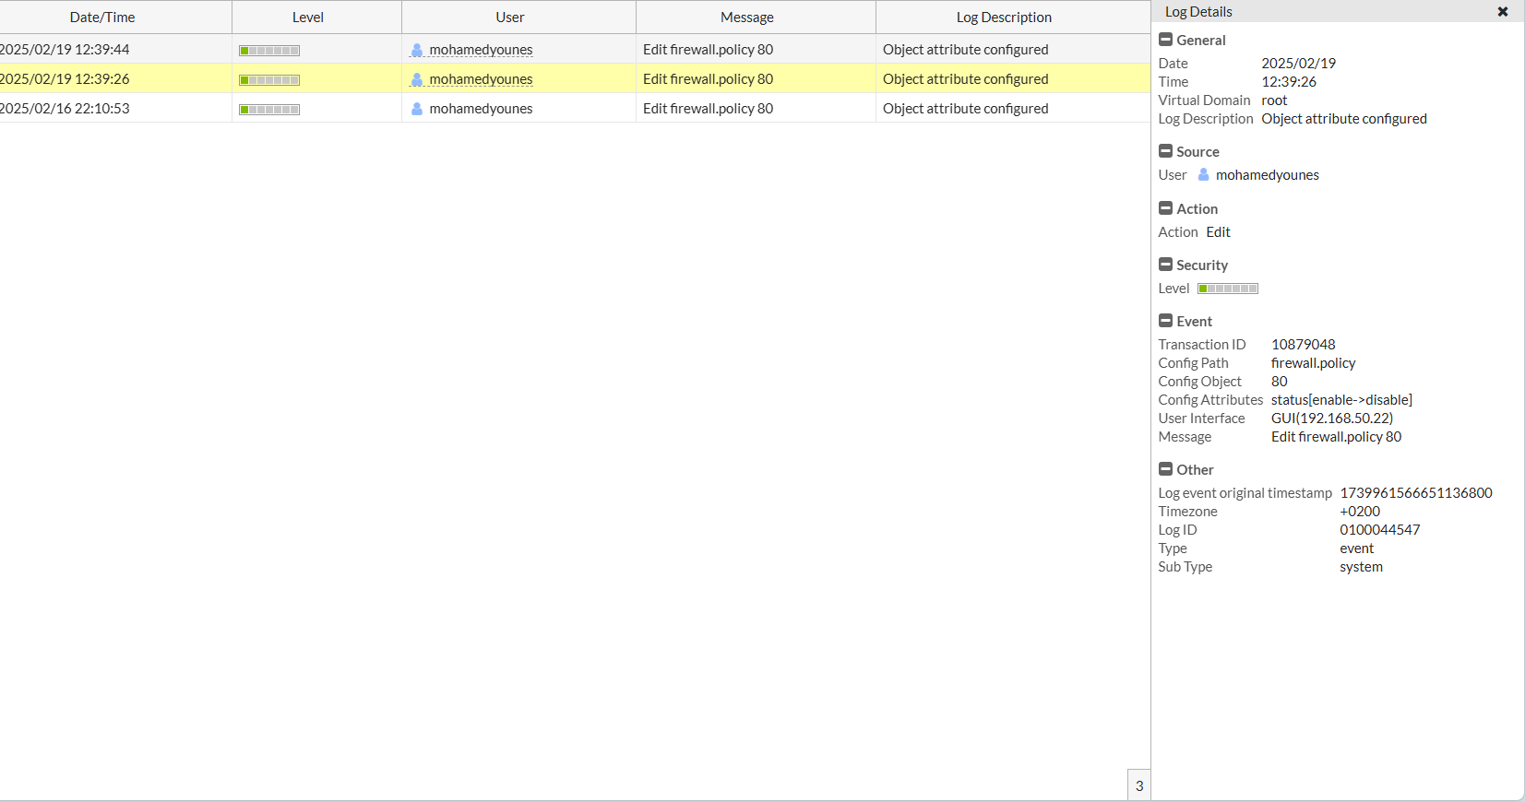

2-Create Email filter on firewall and add it to firewall policies

Changes: Any email traffic through our network will be flirting

Reason: To stop any Phishing & malware emails, protect our network

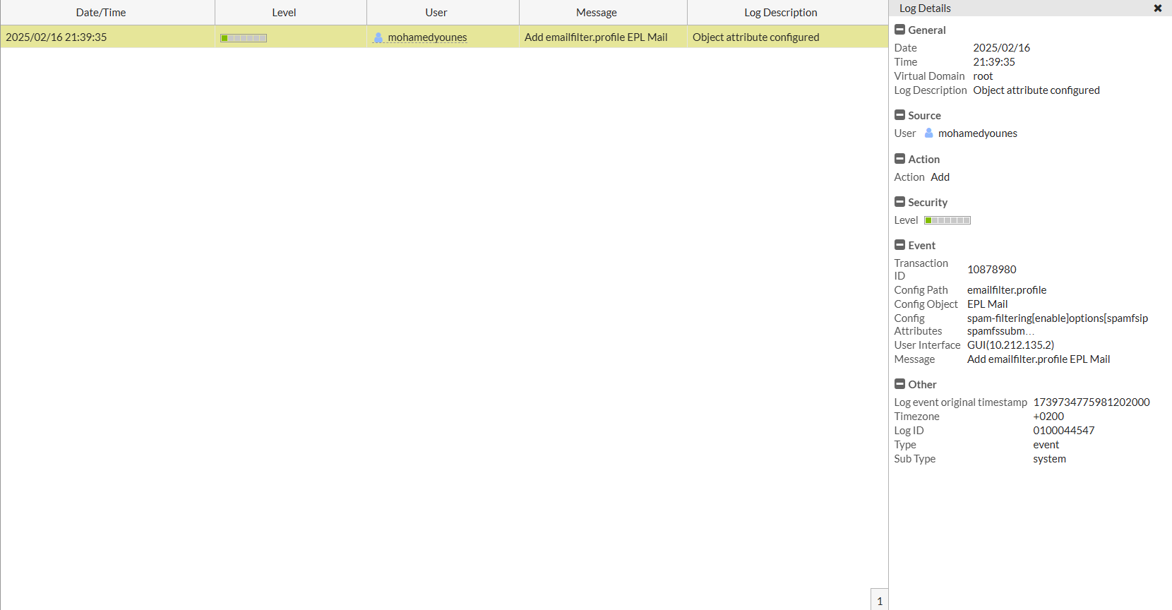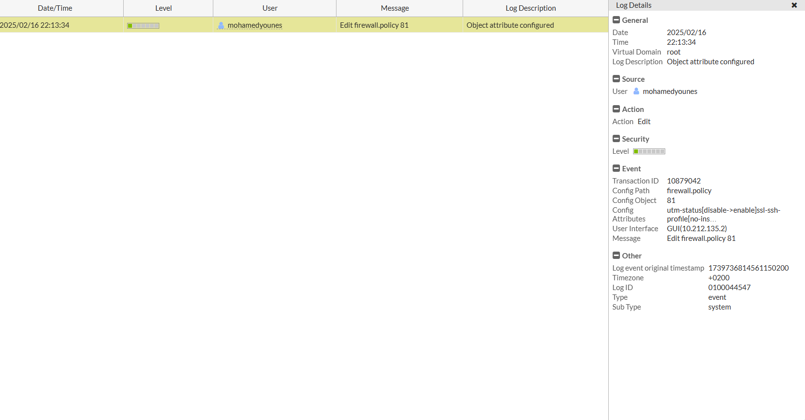

These changes done by IT Team,

Mohamed Younis